Task-1 List all the main components you find inside a desktop PC after opening the cabinet, and write a short description (1-2 lines) for each.

Internal PC Components
- Motherboard: The primary circuit board that connects all internal hardware components, allowing them to communicate and share power.

- CPU (Central Processing Unit): Often called the "brain" of the computer, it executes instructions, processes data, and performs calculations.

- RAM (Random Access Memory): Fast, short-term memory that temporarily holds data for applications and processes currently in use.

- Storage (SSD / HDD): Non-volatile drives responsible for long-term storage of the operating system, software applications, and personal files.

- GPU (Graphics Processing Unit): A specialized processor that handles rendering images, video, and complex 3D graphics for gaming and design.

- Power Supply Unit (PSU): The component that converts AC power from a standard wall outlet into the regulated DC power required by internal parts.

- CPU Cooler & Case Fans: Heatsinks, cooling fans, or liquid blocks designed to dissipate heat from the processor and maintain proper airflow inside the case.

- Cabinet / Chassis: The physical metal and glass enclosure that securely houses, protects, and organizes all internal hardware.

Task-2 Take clear photos or draw labeled diagrams of each step as you disassemble a desktop PC, and organize them in a document with captions explaining what you did at each step. Hint: Include steps like unplugging power, removing side panel, disconnecting cables, and removing RAM, HDD/SSD, and motherboard.

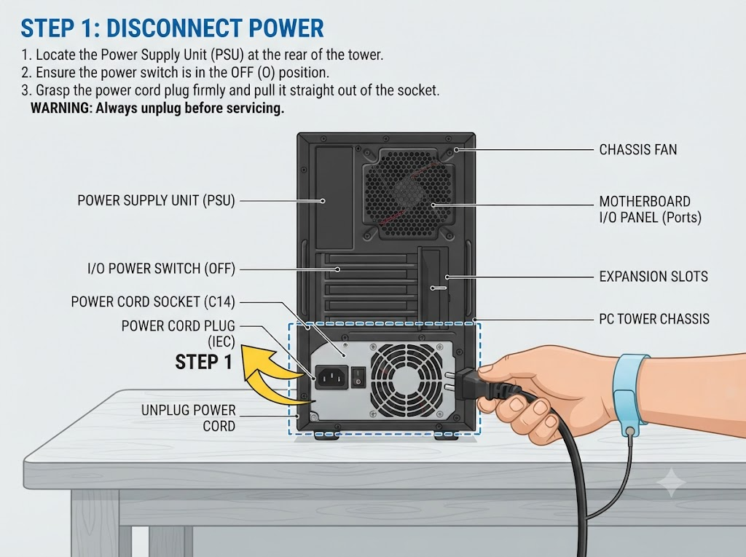

Step 1: Unplugging Power
- Action: Before touching any internal components, ensure the PC is completely powered down and unplug the power cord from the back of the Power Supply Unit (PSU).
- Purpose: This prevents any risk of electrical shock or short-circuiting components while working inside the system.
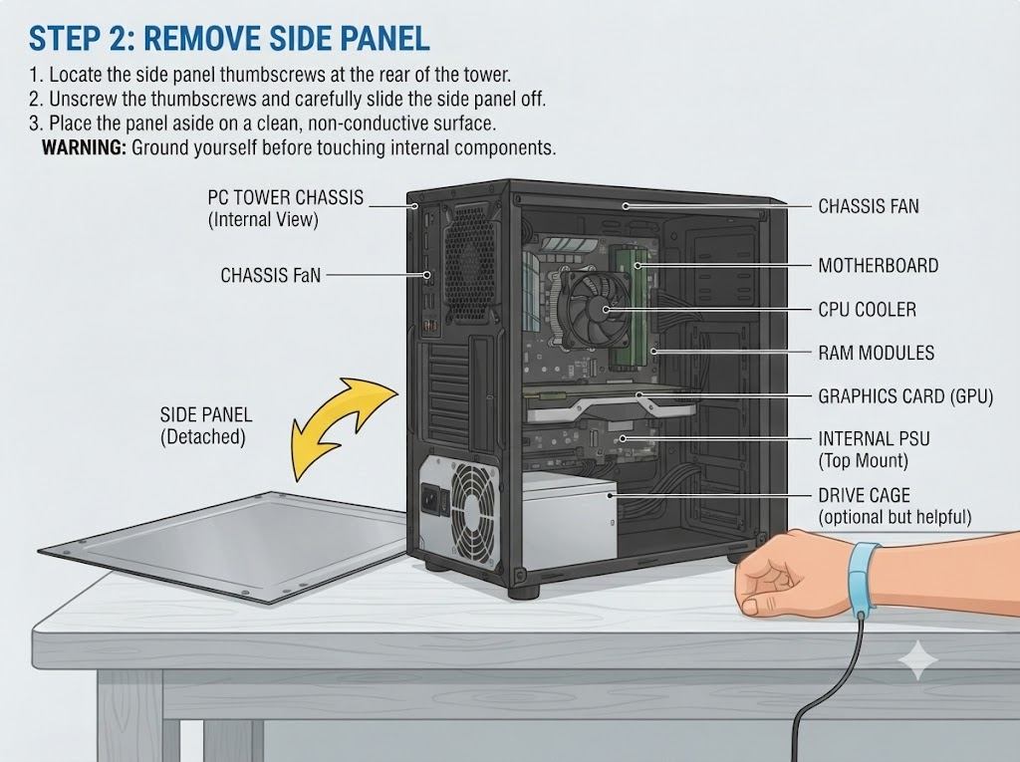

Step 2: Removing the Side Panel
- Action: Unscrew the thumbscrews on the rear edge of the computer cabinet and slide or swing the left side panel outward and off.
- Purpose: This exposes the interior motherboard, cooling system, drives, and wiring harness for servicing.
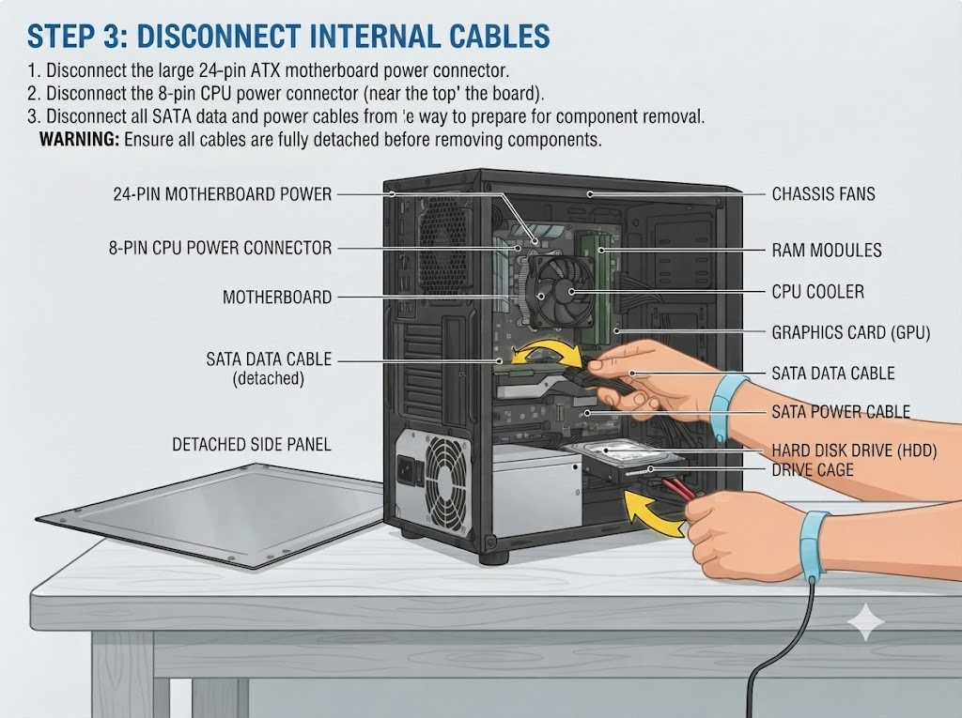

Step 3: Disconnecting Internal Cables
- Action: Carefully unplug all power supply cables (24-pin main power, 8-pin CPU power, PCIe power) and data cables (SATA cables) attached to the motherboard, storage drives, and graphics card.
- Purpose: Clearing cables prevents tugging on fragile connectors and allows free access to individual hardware components.
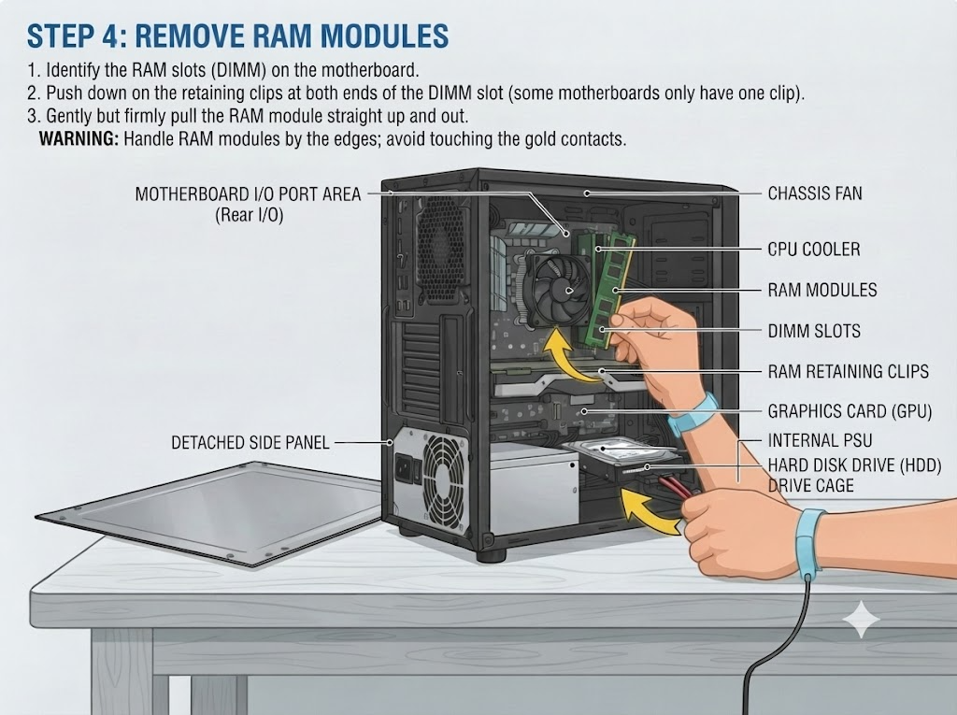

Step 4: Removing RAM Modules
- Action: Push down on the plastic retaining clips at both ends of the DIMM slots until they click open, then pull the RAM sticks straight up out of the slots.
- Purpose: Removing memory early prevents accidental bending or breaking of delicate pins and clears space around the CPU cooler.
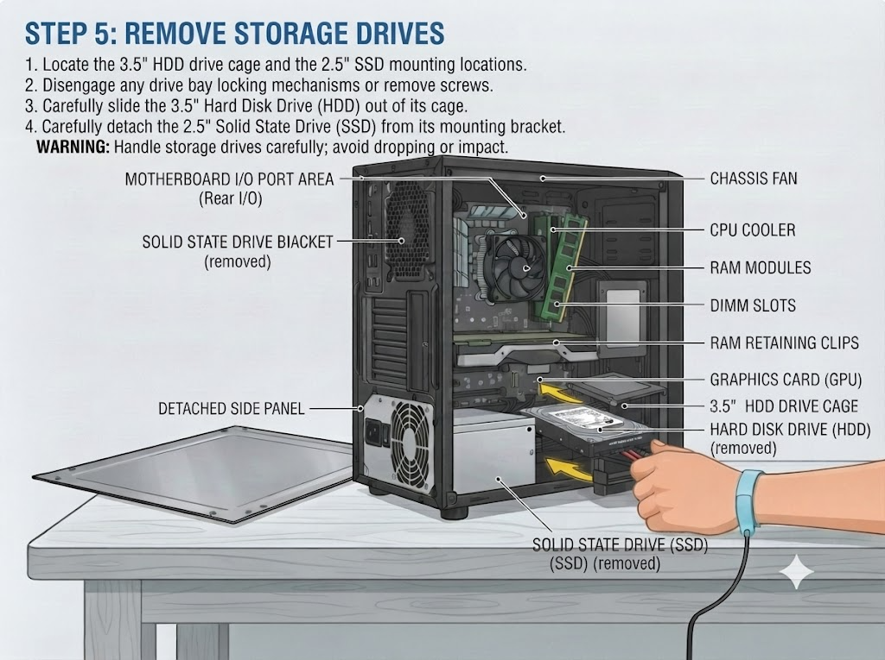

Step 5: Removing HDD and SSD Storage Drives
- Action: Unscrew the mounting screws securing the hard disk drives (HDDs) and solid-state drives (SSDs) in their respective drive cages or mounting brackets, then slide them out.
- Purpose: Extracting storage secures your operating system and data drives and frees up internal chassis space.
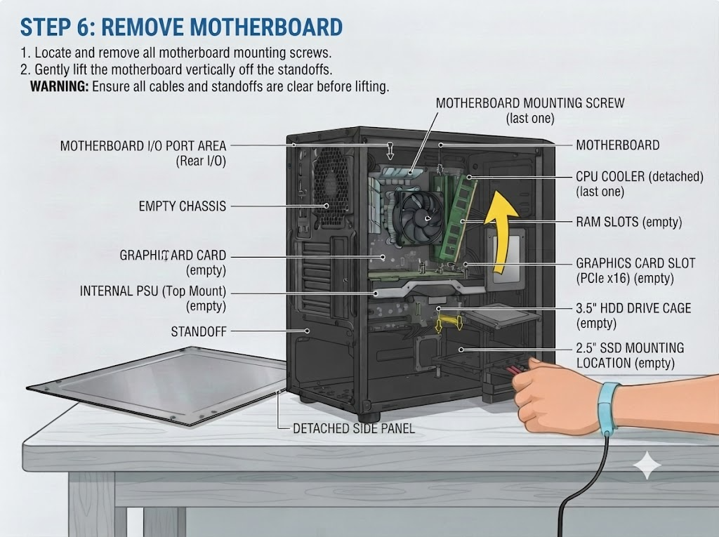

Step 6: Removing the Motherboard
- Action: Disconnect any remaining front-panel connectors (power button, audio, USB), unscrew all mounting screws securing the motherboard to the chassis standoffs, and gently lift the motherboard out of the cabinet.
- Purpose: Completes the core disassembly, separating the main circuit board and attached CPU/cooler from the empty metal chassis.

Task-3 Reassemble the PC you disassembled, documenting each step with a brief explanation of what you connected or installed and why the order matters.

Step 1: Installing the Motherboard
- Action: Place the I/O shield into the rear chassis cutout, align the motherboard with the brass standoffs, and secure it using all mounting screws.
- Why Order Matters: The motherboard serves as the foundational backbone of the PC. It must be installed first into the empty chassis because all other core components (CPU, RAM, expansion cards, and internal wiring) directly interface with or mount onto it.

Step 2: Installing Storage Drives (HDD & SSD)
- Action: Slide the 3.5-inch Hard Disk Drive (HDD) into its drive cage and secure the 2.5-inch Solid-State Drive (SSD) into its mounting bracket, fastening them with screws.
- Why Order Matters: Storage drives should be mounted early while the chassis interior is still open and unobstructed by large cables, power supplies, or graphics cards.

Step 3: Installing RAM Modules
- Action: Open the DIMM slot retaining clips, align the notch on the RAM stick with the slot key, and press down firmly until the clips snap into place.
- Why Order Matters: Installing RAM after the motherboard is secured—but before bulky CPU coolers, graphics cards, or dense cable bundles are routed—ensures unhindered hand access and prevents accidental damage to surrounding parts.

Step 4: Connecting Internal Cables
- Action: Plug in the 24-pin main ATX power connector, the 8-pin CPU power cable, SATA data and power cables, and front-panel header cables.
- Why Order Matters: Cabling must be done after hardware placement so wires can be neatly routed and tied back without interfering with component installation or blocking airflow.

Step 5: Reattaching the Side Panel
- Action: Place the left side panel back against the chassis tracks, slide it securely into position, and tighten the rear thumbscrews.
- Why Order Matters: Enclosing the cabinet protects internal components from dust, physical impact, and static interference, and ensures proper structural rigidity.

Step 6: Plugging in Power
- Action: Ensure the PSU power switch is in the OFF position, plug the AC power cord into the back of the power supply, switch it ON, and test the system.
- Why Order Matters: This is always performed last to guarantee that all internal connections are secure and grounded before electrical current is reintroduced to the system.

Task-4 Create a checklist of safety precautions and tools needed before starting the PC assembly/disassembly process, and explain why each is important.

Essential Tools Needed
- Magnetic Phillips-Head Screwdriver (#2):
  - Why it’s important: Used for standard chassis, motherboard, and drive screws. The magnetic tip prevents tiny screws from falling into hard-to-reach areas inside the PC case and stops screw heads from stripping.
- Antistatic Wrist Strap:
  - Why it’s important: Connects you to a grounded metal object to continuously drain static electricity, preventing Electrostatic Discharge (ESD) from instantly frying sensitive microchips and transistors.
- Magnetic Parts Tray or Small Containers:
  - Why it’s important: Keeps screws, standoffs, and small brackets organized by category so nothing gets lost during the process.
- Flashlight or Headlamp:
  - Why it’s important: Provides direct illumination inside dark chassis corners, making it easy to read tiny motherboard pin labels and connector polarities.
- Zip Ties or Velcro Straps:
  - Why it’s important: Essential for cable management—bundling stray wires prevents them from clipping CPU fans or blocking internal airflow.
- 99% Isopropyl Alcohol & Microfiber Cloth:
  - Why it’s important: Used to clean old thermal paste off CPUs and heatsinks or wipe down dusty surfaces without leaving moisture or residue.

Critical Safety Precautions
- 1. Completely Unplug the PC and Power Supply:
  - Why it’s important: Always disconnect the AC power cable from the wall and switch the PSU power toggle to "OFF" (O). This eliminates live electrical current, preventing severe shock or accidental motherboard short-circuits.
- 2. Work on a Clean, Non-Static, Flat Surface:
  - Why it’s important: Set up on a wooden or rubberized desk. Avoid carpets, blankets, or fabric surfaces, which generate high levels of static electricity that can ruin hardware.
- 3. Ground Yourself Before Touching Components:
  - Why it’s important: Touch an unpainted metal portion of the PC case chassis regularly to discharge any built-up static electricity from your body.
- 4. Handle Components by Their Edges:
  - Why it’s important: Hold motherboards, RAM, and graphics cards by their circuit board (PCB) edges or heatsinks. Never touch exposed gold contact pins; skin oils and sweat cause corrosion and poor electrical contact.
- 5. Never Force Any Component into Place:
  - Why it’s important: Every part is keyed and engineered to fit a specific way. Forcing a component (like inserting RAM backwards or a CPU crooked) will bend fragile pins, crack circuit boards, or break plastic retention latches.

